Top of Form

Industries
Dutch DNA
A biotech startup’s novel gene tests are pushing the limits of medicine…and perhaps ethics.
November 27, 2003
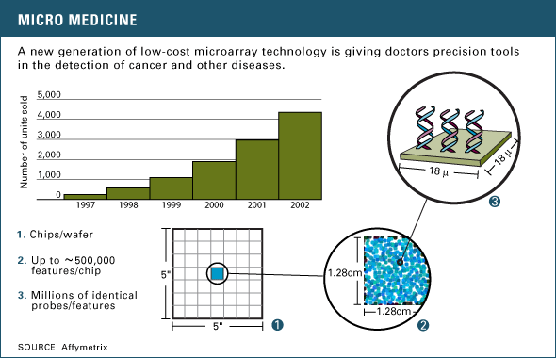
Several months ago, the founders of biotech startup Agendia realized they were sitting on a medical-testing gold mine. Agendia had developed a low-cost diagnostic test based on microarray technology that offers doctors pinpoint accuracy in determining a patient’s predisposition to various types of genetic diseases. Early results from a breast cancer trial in Amsterdam were extremely promising.
So promising, in fact, that Agendia began marketing its gene tests to physicians and breast cancer patients before the trial was complete. The company’s aggressive push to commercialize its DNA tests is stirring up controversy in medical circles. “If Agendia’s test [and others like it] have not gone through that baseline [U.S. Food and Drug Administration (FDA)] approval process, I am not sure it meets the standard of practice,” says Dr. Fred Silva, Executive Director of the United States and Canadian Academy of Pathology (USCAP).
Microarrays consist of glass chips that are spotted with laboratory-grown portions of DNA – called probes – during the manufacturing process. To run a DNA test, researchers prepare DNA from a patients’ tissue or blood and label it with a fluorescent dye. The labeled sample is then dropped onto the biochip, and the chip is zapped with a low current of electricity, which forces the patient’s DNA to move around. The patient’s DNA is pushed past the DNA probes bound to the chip. When sample and probe match, the two stick together and create a colored spot on the chip. After the test is complete, scientists use a computer to scan the resulting pattern of spots to make a diagnosis (see Biochips Explained).
- ADVERTISEMENT -

Beginning this fall, Netherlands Cancer Institute (NKI) researchers in Amsterdam will use results from Agendia’s microarray tool to decide whether to assign breast cancer patients standard or aggressive therapy regimens.
The microarray, a marriage of microelectronics and molecular biology, is capable of simultaneously scanning the activity of thousands of DNA segments. Agendia partnered with gene chipmaker Agilent Technologies, based in Palo Alto, California, to help it design and build the microarray test. The microarray, developed in collaboration with researchers at Rosetta Inpharmatics in Seattle, is able to track 70 genes and their genetic expression pattern when breast tissue becomes cancerous.
It is not just the tool’s precision that has captured the medical community’s interest. The cost benefits are also significant. A typical breast cancer treatment regimen costs about 3,000 euros ($3,536) in Holland and about $7,000 to $8,000 per patient in the U.S. Agendia’s microarray tests, however, are expected to cost $1,200 to $1,600.
What is the market for microarray technology? According to Agilent, the microarray industry has experienced double-digit gains every year since its inception in the early 1990s. Agilent is now shipping more than 20,000 microarrays per quarter at about $1,200 apiece, which is roughly 10 percent of the microarray market. Microarray pioneer Affymetrix boasts 50 percent market share of the microarray market.
Thus far, however, microarray technology is still young. And that is another reason why researchers and entrepreneurs have their eyes on the NKI group. If successful, Agendia will be the first company to move a multi-gene test into the clinical arena.
Agendia plans to validate its testing tool based on forthcoming results from a prospective study, which is designed to predict how patients will fare before the treatment regimen begins. The testing tool was first available to Dutch cancer patients this fall.
In this area, NKI researchers in Amsterdam are taking bold steps. In three pioneering trials involving a total of 13,000 patients younger than 55 years old with lymph node negative breast cancer, the NKI investigators plan to use the tests to determine half the participants’ therapy.
NKI researchers point out that up to 85 percent of breast cancer patients in Europe and 95 percent of patients in the U.S. are told they need chemotherapy based on traditional diagnosis. The NKI researchers found in retrospective tests that the gene test will send only 50 to 55 percent of breast cancer patients to chemotherapy. Researchers believe a highly accurate testing tool will permit them to identify 25 to 30 out of every 100 women and spare those patients the nauseating, debilitating, overall misery of chemo treatments – and its high cost of treatment.
That potential cost savings has captured the Dutch Health Council’s attention. It is now sponsoring the first of the three NKI trials that will gauge whether the costs of microarray testing will reduce the total number of patients requiring chemotherapy – and thus, reduce overall medical costs. “We will convince the whole world that this is a very elegant way to get rid of unnecessary chemo,” says Dr. Emil Rutgers, a surgical oncologist and one of the NKI trial’s designers.
In the meantime, Agendia investigators plan to market the gene tests to breast cancer patients, at least in Europe, even though results from the test will not be complete for up to five years. Agilent will manufacture the 70-gene microarrays for both the NKI clinical trials and Agendia will perform the eventual commercial testing at a laboratory located at the NKI campus in Amsterdam. “These multi-component tests have the power to change medicine,” says Dr. Lou Staudt, senior investigator at NCI. “It is an extraordinary time for molecular diagnosis.”
Researchers like Dr. Silva at USCAP have trouble with the potential conflict of interest in the NKI and Agendia trial. The problem, he says, is that Agendia is playing in two arenas, yet claims neutrality with regard to the clinical trial test. Dr. Silva claims that Agendia would benefit financially if the microarray tests succeed.
Not true according to Agendia. The company says its lab is taking the appropriate and “necessary” steps to insure against this conflict of interest. “There is no possibility for a conflict of interest for two reasons,” says Agendia co-founder Rene Bernards. “First, the European Organisation for Research and Treatment of Cancer in Brussels (EORTC), the most reputable clinical trial organization, is in charge of the trial. Agendia will receive blind samples from Brussels. In addition, Agendia assigns these patients to either a ‘high risk’ or ‘low risk’ group within 10 days after receiving the samples.” After Agendia has reported their risk status to EORTC, patients, if they develop metastases at all, can take between 1 and 10 years to do so, says Mr. Bernards. After one and three years, EORTC will compare Agendia’s prediction with the actual outcome.
Currently, the Agendia group is working rapidly toward achieving certification from the International Organization for Standardization (ISO) and European Conformity, both marks of quality in lab and manufacturing practices. Mr. Bernards expects that certification will come within six months. At that point, Agendia will begin sale of the tests in Europe.
Agendia researchers will also have to steer through the regulatory process with the U.S. Food and Drug Administration (FDA). The agency has, in the past, approved “home brew” tests for commercial use—defined as tests done by a single site lab for diagnostic purposes. This means that if the FDA approved the Agendia test, it would not allow the company to sell the microarrays in the U.S. However, the company could market the test results, according to Steve Gutman, director of the FDA’s office of in-vitro diagnostics.
If Agendia succeeds, it would be the first European Conformity-marked microarray lab and the first company to sell a multi-gene test for clinical use. “This trial is the one that everybody is excited about,” says Paul Metzler at NCI. “It looks like a big payoff in terms of [gene tests] telling us something important about tumor biology.”
Copyright © 1993-2004 Red Herring, Inc.
Bottom of Form

